YMWREA 2024 Membership Quick Facts Sheet

Applicant Requirements
• Be engaged in real estate for at least two years, including one year in New York
• Must be at least twenty-three (23) years of age and apply for membership prior to their forty-fourth (44th) birthday.
• Attend at least eight events (of which four must be luncheons) within a twelve-month period of your application submission.

Application Process
• Complete an application and submit it prior to the below due dates.
• Applications must be submitted along with two sponsoring letters and two seconding letters from current YMWREA members (Note, only one of the two sponsoring letters and one of the two seconding letters can be from your own firm. Additionally, sponsors and seconders must be members of YMWREA for a minimum of 2 years and personally know the applicant for at least 1 year).
• After submitting the application, a member of the Membership Committee (see back for committee members) will reach out to schedule an informal pre-interview.
• Sit for a formal interview with the Membership Committee (see below for dates).

Important Dates
• Spring Applications Due: Friday, May 10th, 2024
• Spring Formal Interview: June 2024
• Fall Applications Due: Friday, October 18th, 2024
• Fall Formal Interviews: November 2024

Tips
• Register to receive all YMWREA emails regarding upcoming events at
https://ymwrea.org/register/
• Download the application from https://ymwrea.org/join/
• Keep a list of all events you attend to track your progress.
• A list of current YMWREA members can be found at the back of the application in order to help you identify sponsors and seconders.
• Get to know members of the Membership Committee.
• Encourage your sponsors to review your application before you submit.
• Reach out to the Membership Chair Christopher Turner (cturner@denhamwolf.com) with any questions or to submit your application.

**It is the Applicant's responsibility to read the application carefully to ensure you follow the above requirements**

2024 Membership Committee

David Brause* 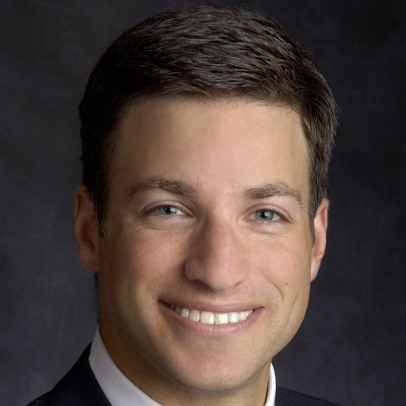 | Rick Brickell 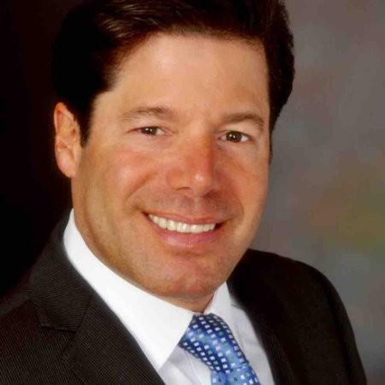 | 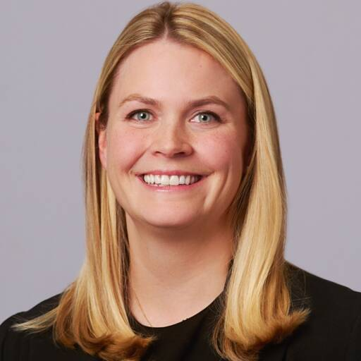  Alexandra Budd | Lauren Calandriello*
AJ Camhi | Garry Curry | 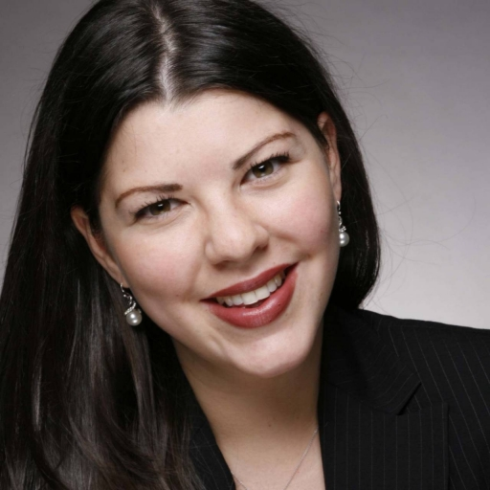  Robin Fisher | Matt Fox
Adam Green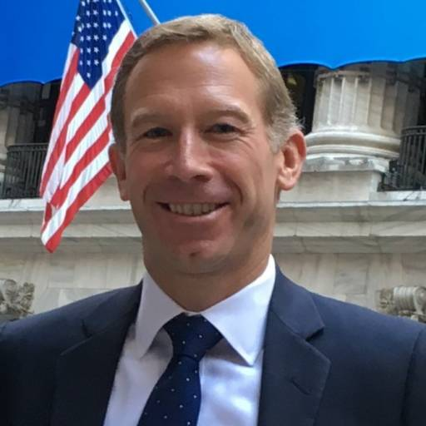 | Joe Grotto*  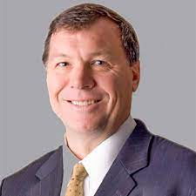 | Nicky Heryet* | Laura Jackson*  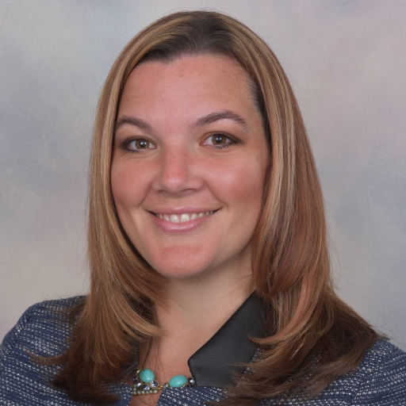
Todd Korren  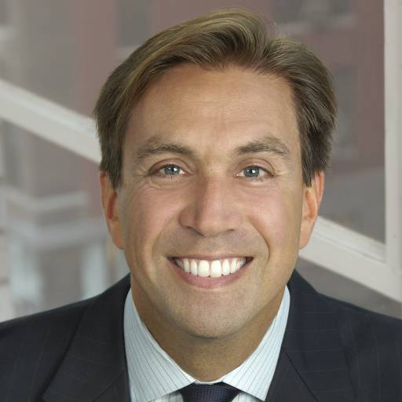 | Lenny Lazzarino* 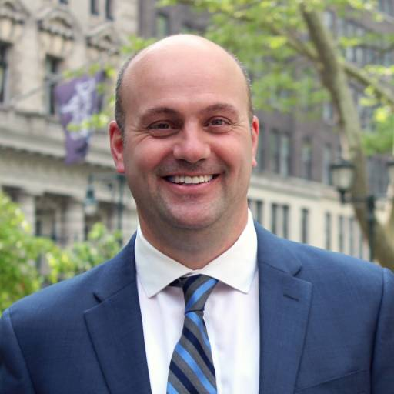 | Ron Lo Russo | Camille McGratty*
Caroline Merck* 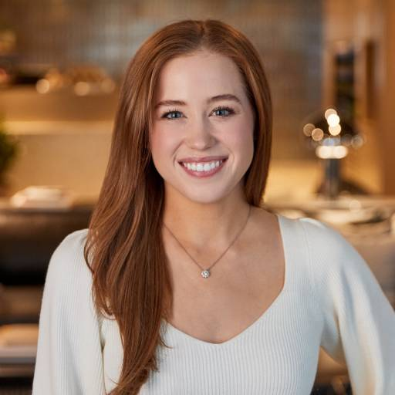 | Bill Montana*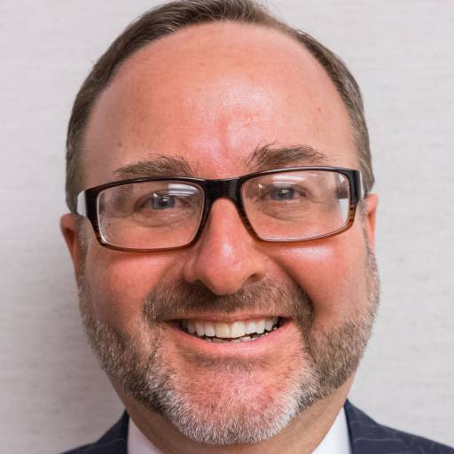 | James Nelson*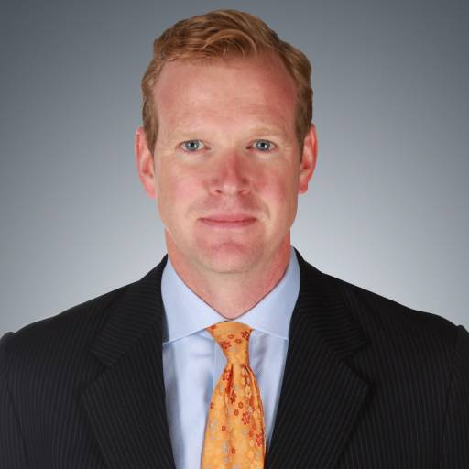 | Lindsay Ornstein*  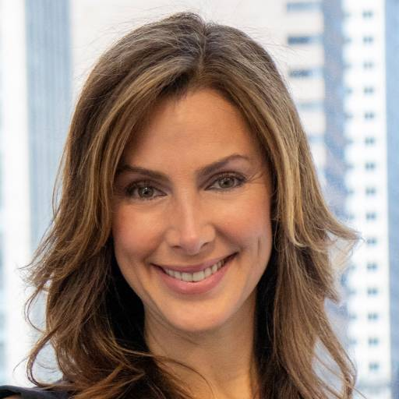
Rob Shapiro*  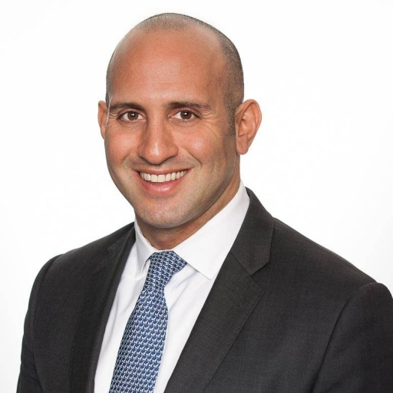 | Jonathan Tootell* | Kylie Van Buren | Craig Waggner  